EV Charging Connector Types: Global Comparison
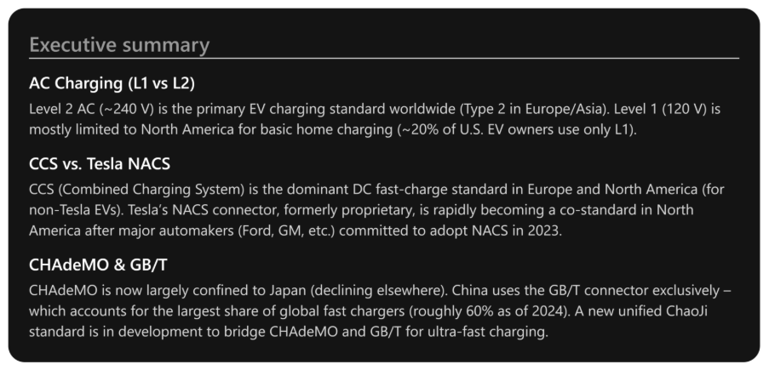
Electric vehicle (EV) charging connectors vary by region and charging speed. AC Level 1 and Level 2 refer to slower AC charging (using onboard chargers), whereas CHAdeMO, CCS, GB/T, and Tesla/NACS are DC fast-charging standards. The table below compares these main connector types by where they’re used, how widely adopted they are, and current trends or standardization movements for each:
Connector Type | Geographic Prevalence (where used) | Adoption (% share) | Current Trends & Standardization
AC Level 1 (120 V AC) | North America (U.S., Canada) primarily; rare elsewhere. Standard 120 V wall outlets (e.g. NEMA 5-15 plug) serve as Level 1 EV chargers¹ ². | Limited use: Only ~20% of U.S. EV owners rely exclusively on Level 1 home charging³. Virtually 0% of public charging stations in the U.S. offer L1 (public infrastructure favors faster Level 2 or DC charging)⁴. | Trend: Gradually declining as EV owners upgrade to faster Level 2; Level 1 remains a “convenience” option for overnight charging or where 240 V is unavailable. All EVs support L1 by default, but its share of total energy delivered is low and expected to shrink over time⁵.
AC Level 2 (208–240 V AC) | Worldwide – Primary AC charging method globally. North America and Japan use the SAE Type 1 (J1772) connector for Level 2, while Europe, Asia, Oceania, etc. use the Type 2 (Mennekes) connector⁶. Often installed at homes, workplaces, and public destinations. | Dominant AC standard: ~70% of global public charging points are AC Level 2 (≈2 million out of 2.7 million total chargers). In the U.S., ~80% of EV owners have access to Level 2 charging at home (74% L2-only + 6% both)⁷. Virtually all modern EVs can charge on Level 2. | Trend: Continued expansion as the backbone of daily EV charging. Many countries have building codes and incentives favoring Level 2 installations. Europe has standardized Type 2 as the universal AC connector⁸. Level 2 is expected to handle the bulk (≈80%) of all EV charging needs through 2030⁹. Innovations include smarter load-sharing and integration with renewable energy at Level 2 chargers.
CHAdeMO (DC) | Japan (the originating standard) – historically also used in some U.S. and European stations (notably by Nissan for LEAF, Mitsubishi, etc.), but being phased out elsewhere. Few new CHAdeMO installations in Europe or North America post-2020s¹⁰. | Declining: Accounted for only ~9% of new DC fast charger installations globally in 2023¹¹. Japan still maintains 30,000+ CHAdeMO fast charging points¹², but globally CHAdeMO’s share of fast chargers is now small (on the order of 5% or less). Most new EV models outside Japan have dropped CHAdeMO ports in favor of CCS or NACS. | Trend: Phase-out in Western markets; networks in the EU and U.S. rarely add new CHAdeMO plugs (e.g. EU law since 2017 effectively requires CCS on new high-power chargers)¹³. CHAdeMO 3.0 (ChaoJi) has been co-developed with China to support >500 kW (up to 900 kW target) and unify with China’s standard¹⁴ ¹⁵, but this next-gen connector may primarily see adoption in Asia. CHAdeMO’s unique advantage, vehicle-to-grid (V2G) capability, remains in niche use (mainly in Japan)¹⁶ ¹⁷.
CCS (Combined Charging System) (DC) | North America & Europe – CCS is the default fast-charge interface for most EVs in these regions (CCS1 combo plug in US/Canada, CCS2 in Europe). Also adopted in Korea and growing elsewhere. Not used in China (which uses GB/T). | Mainstream: Over 58% of new EV models globally come with CCS fast-charging ports¹⁸. More than 110,000 CCS fast chargers are in operation worldwide¹⁹ – roughly ~15% of global fast chargers. In Europe, CCS is nearly ubiquitous (over 80% of new fast chargers in 2023 had CCS)²⁰. In North America (pre-2023), CCS1 was standard on non-Tesla vehicles, with thousands of stations deployed. | Trend: Global standardization (outside China/Japan). The EU established CCS2 as the required connector for all new public DC chargers from 2017²¹, ensuring continent-wide interoperability. In North America, CCS1 faces new competition from NACS (Tesla’s connector) as Ford, GM, and others plan to switch to NACS ports from 2025²². However, U.S. federal funding still mandates CCS* availability, so many charging sites will offer both CCS and NACS in the interim. Efforts are underway to enable bidirectional charging and higher power via CCS (e.g. testing ISO 15118 Plug&Charge, future CCS updates), to close feature gaps with CHAdeMO. Overall, CCS remains the most widely adopted open fast-charge standard worldwide²³.
GB/T (DC) | China – Exclusive standard in China for DC fast charging. Nearly all Chinese EVs (domestic and foreign models sold in China) use the GB/T DC charge port. Rarely seen outside China. | Largest share: Over 450,000 GB/T DC fast chargers in China as of 2024²⁴ – roughly 60% of all DC fast chargers worldwide. (China had ~530k of ~730k global fast chargers in 2024, the majority using GB/T.) As China leads in EV deployment, GB/T by sheer numbers has the highest adoption of any single standard. | Trend: Continuous expansion with China’s EV growth. State-owned utilities (e.g. State Grid) are upgrading networks with higher power (new GB/T stations up to 250–500 kW)²⁵. ChaoJi (co-developed with Japan’s CHAdeMO group) is poised to become the next-gen standard – China’s version is sometimes called “New GB/T” – enabling much higher power and backwards compatibility via adapters²⁶ ²⁷. China is expected to migrate to this ultra-fast standard in coming years, which would merge the CHAdeMO and GB/T ecosystems. Internationally, GB/T remains a China-only solution, as other regions standardize on CCS or NACS.
Tesla NACS (North American Charging Standard) – formerly Tesla proprietary connector (DC & AC) | North America – Used by Tesla vehicles in the U.S. and Canada for both AC and DC charging (in other regions Tesla vehicles use the local standard, e.g. CCS2 in Europe). As of 2023, Tesla’s NACS connector dominates U.S. fast charging by volume of use²⁸, thanks to Tesla’s extensive Supercharger network. | High (and growing): Tesla operates ~50,000 Supercharger plugs globally²⁹, including over 19,000 in North America³⁰. Tesla’s network makes up roughly half of all U.S. DC fast chargers (19k out of ~37k in 2024)³¹ ³². Until recently, NACS was limited to Tesla cars, but in 2023 a wave of major automakers (Ford, GM, Rivian, Mercedes, and others) agreed to adopt NACS on new EVs from 2025 onward³³. This industry shift means NACS is likely to become a de facto standard alongside CCS in North America. | Trend: Standardization and expansion. In 2022, Tesla opened NACS as an open standard and in 2023 SAE International agreed to standardize it (published as SAE J3400)³⁴ ³⁵. By late 2023, the U.S. government officially endorsed NACS (along with CCS) for nationwide charging infrastructure³⁶. Charging networks and equipment makers are adding NACS connectors to stations to accommodate the growing number of NACS-equipped vehicles. Outside NA, Tesla continues to use CCS2 and other regional plugs, but NACS is on track to become a North American standard, with broad cross-industry support ensuring compatibility for non-Tesla EVs³⁷ ³⁸.
Sources: All data compiled from industry reports, government agencies, and manufacturer disclosures. Key references include the U.S. Department of Energy and Pew Research for charging statistics³⁹, Plug In America’s EV owner survey for home charging behavior⁴⁰, the CHAdeMO Association and InsideEVs for ChaoJi standard details⁴¹, market analysis for charger counts and shares⁴², and official announcements (EU directives, SAE press releases, automaker statements) regarding standardization movements⁴³ ⁴⁴.

Key Developments in Connector Standards (2017–2024)

In summary: The world is converging toward a few dominant EV charging connector standards. CCS is firmly entrenched in Europe and much of the world outside China, while Tesla’s NACS is rapidly emerging as a new North American standard (alongside CCS) due to its adoption by multiple automakers and formal standardization. CHAdeMO, once popular, is receding to a Japan-only role as CCS and NACS take precedence in Western markets. China’s GB/T standard stands apart by virtue of China’s huge EV market, though a future alignment with Japan via ChaoJi could create a unified Asia-specific standard. For AC charging, Level 2 connectors (Type 1/Type 2) remain the universal solution for home, workplace, and destination charging, supporting the majority of EV charging sessions worldwide. Going forward, continued emphasis on interoperability (e.g. stations with multiple connector types), combined with international standardization efforts, aims to ensure that EV drivers can plug in and charge seamlessly wherever they go⁴⁵ ⁴⁶.

